OpenShift Containerization POC 2026 – POC Test Protocol
Number: | 021 | Test Date: | 11. Feb 2026
Test Owner: | Naga Krishna Sai Baruri
Comments: | Enable AD Authentication

Test Results
Test was Successful. | ☒
Test was successful with constraints. | ☐
Test failed | ☐

Test Objective (Evaluation Criteria / Requirements)
We need to enable AD Authentication so that users with AD account can login to OCP with defined RBAC

Expected Result
After creating the LDAPs AD authentication, the AD user should be able to login.

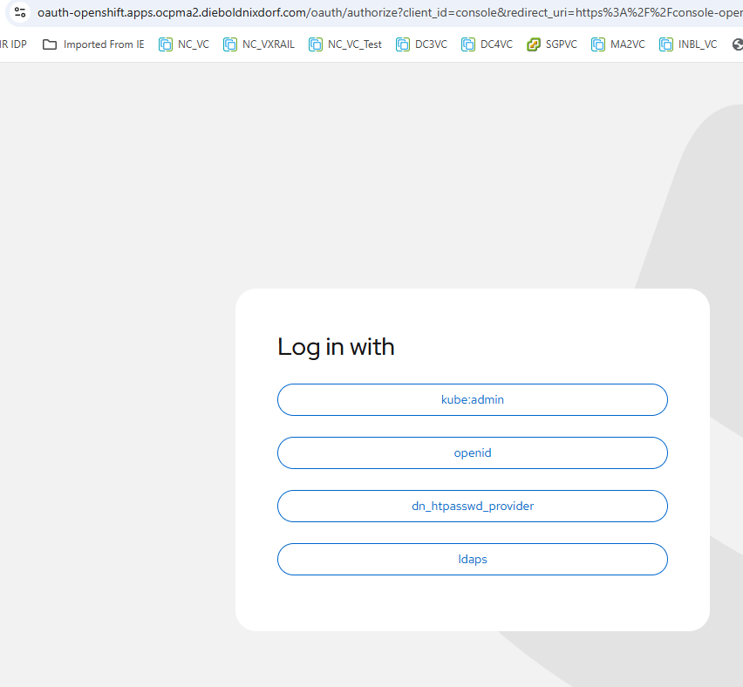

Test Results
- Login into OCP web GUI
- Under Administration select cluster setting and redirect to cluster configuration.
- Select OAUTH

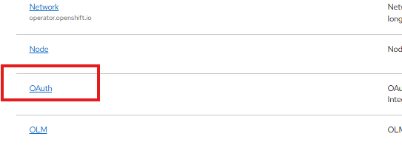

- Under identity providers click add and select LDAP.

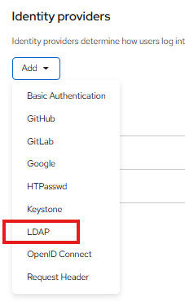

- Fill in the needed details as given the screenshot and click add.

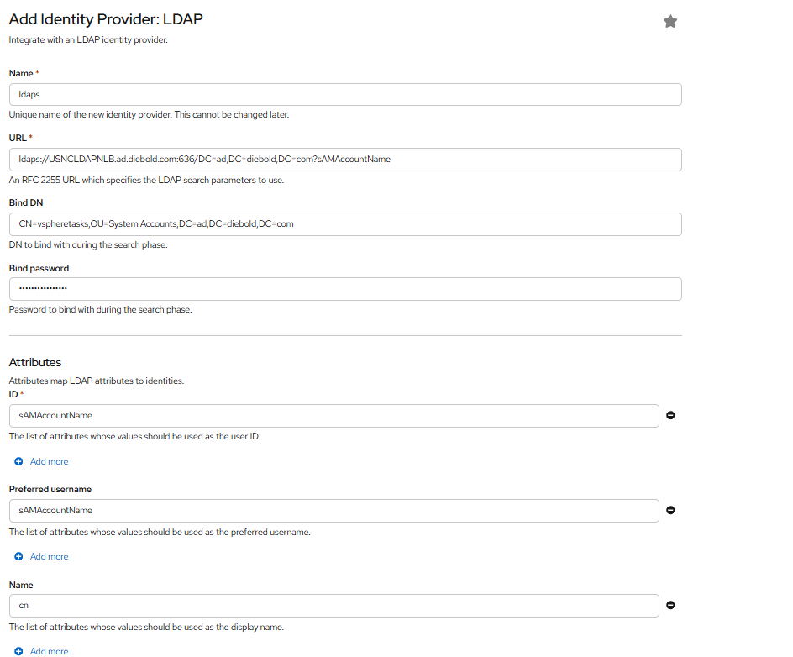

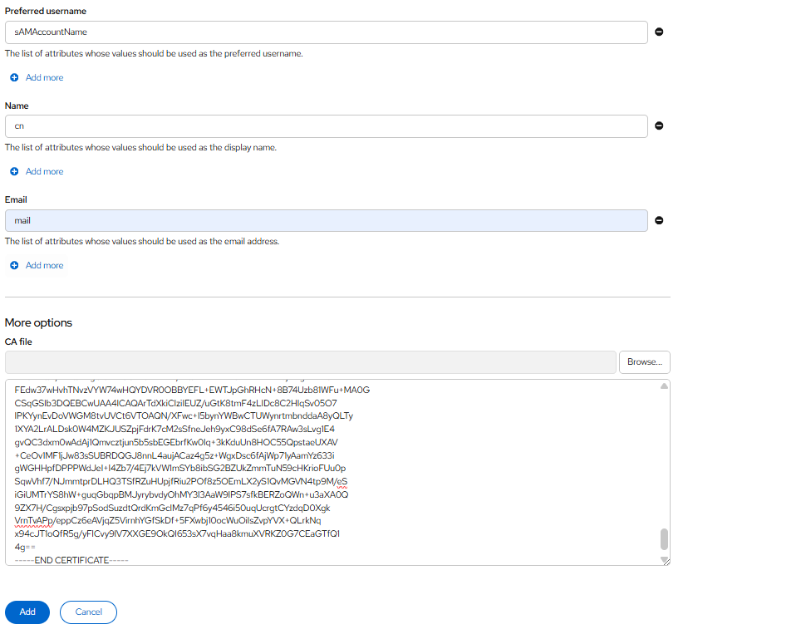

- Wait till the Openshift-Authentication pods are recreated and post this we should be able to login via AD user using LDAPs as identity provider.

